How to uninstall U9 Auto-install Wireless Adapter driver?

Use Windows 7 as example：

Step 1: Open “Control Panel”, tap “Programs and Features”

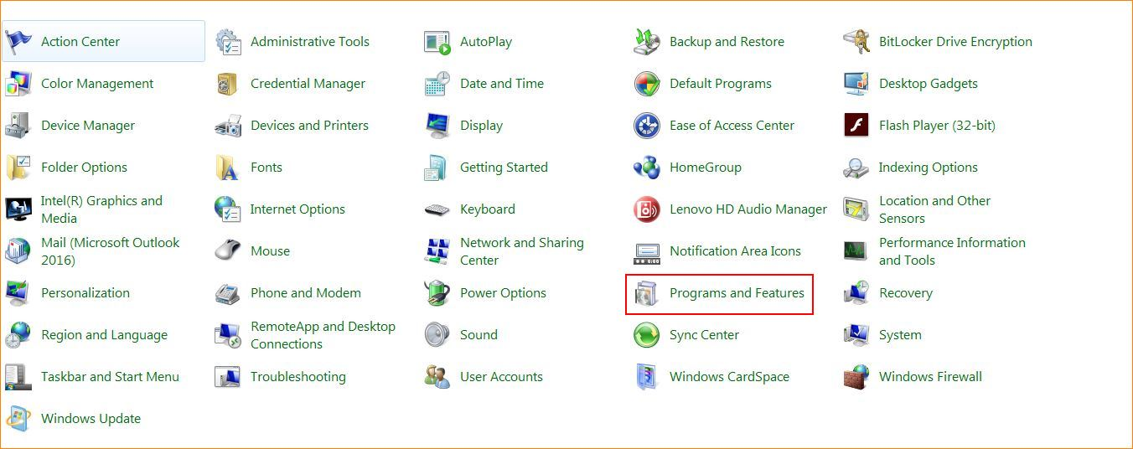

Step 2: Find drive “Tenda Wireless Adapter”, choose “Uninstall”.

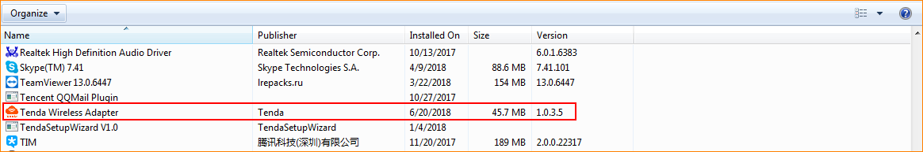

Step 3: Tap “Uninstall/Change”, tap “Yes” to uninstall the software.

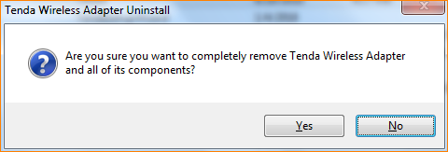

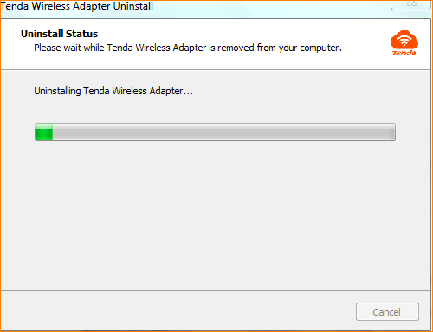

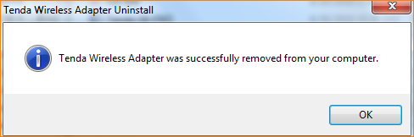

Step 4: Please restart PC.

Note：
If you uninstall the drive with plugging adapter into PC, please unplug it after finishing uninstallation.

